The following guide is meant to compliment the Every Day Objects lesson. These activities are meant to help students develop a more in depth understanding of the simalrities and differences of Ethiopian and Western cultures and lifesytyles.
Ethiopian Every Day Objects Extension Activities
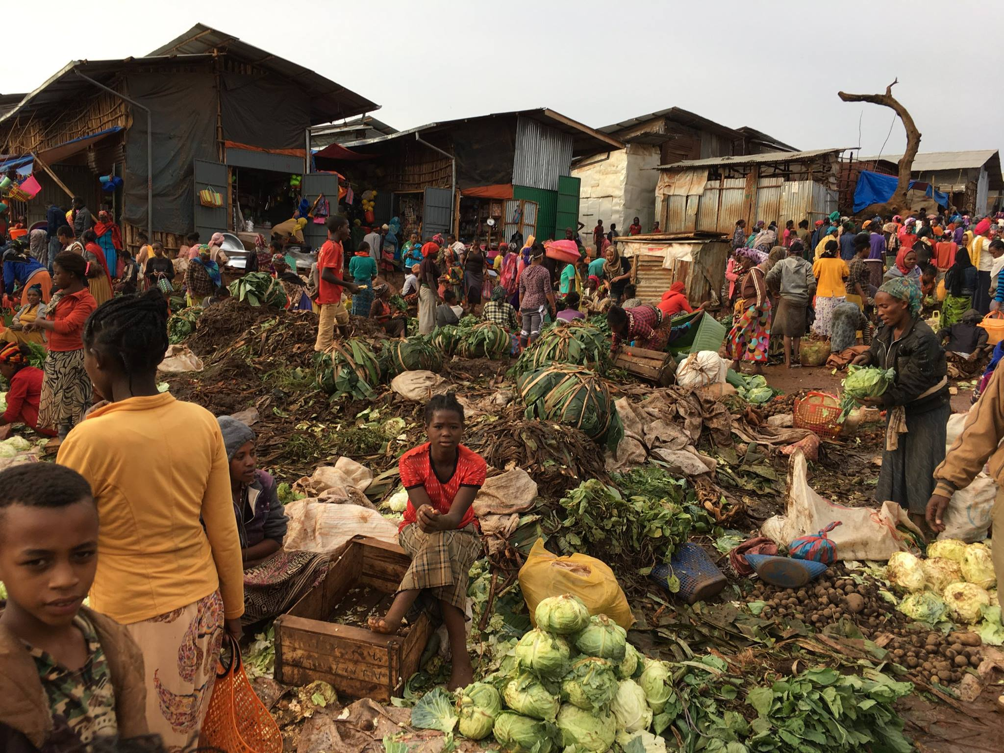
Everyday Objects Extension Activities
The following list includes hands-on, STEM and literacy activities that can enhance knowledge of the objects. Some of the activities require the use of actual objects. If these artifacts are not available, teachers are welcome to substitute available resources. It is recommended that educators contact the University of Pittsburg African studies program to try and obtain these objects. Some activities provide website links to engage students in the craft process of making of the objects.

1 Baskets, Scarves, and Bags (Objects #1,2,3)
Activity #1 Paper Weaving………………………………………………………………Pg. 2

2. Clay Pots (Object #4)
Activity #2 Picture Sequencing…………………………………………………….......Pg. 4
Activity #3 Pinch Pots……………………………………………………………………Pg. 8

3.Wooden Objects (Object #6)
Activity #4 Toothpick Structures………………………………………………………Pg. 9

4 Flags (Object #7)
Activity #5 Design your own Flag……………………………………………………..Pg.10

5. Toys (Object #8)
Activity #6 Recycled Toys………………,……………………………………………. Pg.11
Activity #7 Mancala Board Game……………………………………………….........,Pg.12

6. Food Labels (Object #9)
Activity #8 Design your own Food Label…………………………………..............Pg. 14

7. Mortar and Pestle (Object #10)
Activity #9 Using a Mortar and Pestle…………………………………………….…Pg. 15

8. Plastic Shoes (Object #12)
Activity #10 Your Shoe’s Story…………………………………………………….....Pg. 16

Paper Weaving

Students will try their own form of weaving. This can be accomplished with grasses, paper, or numerous other resources that are available. Many example of weaving projects available online and in craft stories. The level of complexity you choose can be based on your available resources and time.

The following lesson plan can be used in your classroom. The plan has been adapted from the Dickblick Art Supplies website. (http://www.dickblick.com/lessonplans/paperweaving/)

Paper Weaving Lesson Plan

  In this project, the student will use two pieces of colored construction paper to produce a woven paper mat.
  Weaving is one of the most ancient forms of human creativity. Baskets and textiles would not have been possible without weaving. This project will give students experience working with the basic concept of weaving.
  Grade Levels
  Elementary through Junior High, and Special Education.
  Time Required
  One class period (45 - 60 minutes a period)
  Lesson Objectives
  To a develop basic knowledge and gain experience with weaving. Students will produce a simple weaving project and will be able to discuss the basic vocabulary of weaving.
  This project is a practical introduction to textile weaving for younger students or anyone with no weaving experience.
  Procedure
  - The teacher may prepare a sample(s) ahead of time for showing to the class. Begin with a brief discussion of weaving and what it is (the interlacing of threads to form a continuous piece of fabric). Write vocabulary list on board and discuss. Show example(s).
    - Weaving — The process of forming cloth or fabric on a loom by interlacing yarn or thread (or, as in this case, paper).
    - Loom — A frame for weaving yarn or thread into cloth or fabric.
    - Warp — Threads running lengthwise on the loom. The warp is placed on the loom prior to beginning the weaving process.
    - Weft — Threads that are weaved across the warp threads to form the web.
    - Web — The cloth or fabric produced by weaving.
  - Distribute materials and tools.
  - Students fold one sheet of paper horizontally.
  - Draw a line about one inch from the open end of the folded paper. This is the limit of cutting.
  - From the fold, make irregular cuts up to the line. Cuts need not be straight. (The irregular cuts make a more interesting finished product.) Unfold and lay it flat. This will serve as the "warp" and the "loom."
  - Measure and cut from the second sheet of paper, one-inch wide by nine-inch strips. These will serve as the "weft." Tip: Teacher may precut the one-inch weft strips.
  - Begin by weaving one "weft thread" over one "warp thread" then under the next warp and over the next, etc.
  - Continue this process alternating over and under with each weft thread. If the previous weft thread went under the warp thread, the following row will begin by going over the warp.
  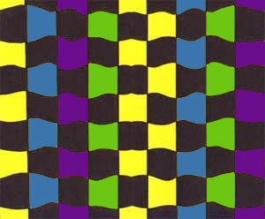
  Materials
  1. Two 9" × 12" sheets of construction paper in different colors per student. | 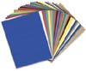
  2. Glues | 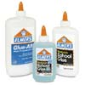
  3. Rulers and Measurement Tools | 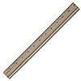
  4. Scissors, Trimmers, and Shears | 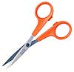
  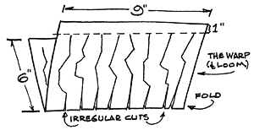
  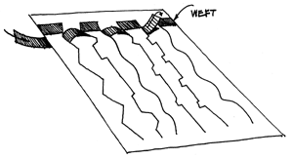

Making a Coffee Pot with Sequenced Pictures

On the following page, there are pictures of how the Ethiopian coffee pot is created out of the clay. Cut up the pictures and give to students. Students should sequence the pictures. The details will provide clues. This process is described in the video. Students can watch this segment of the Ethiopian Expedition video before putting pictures in order. They can also use it to check their answers. Teachers can choose to make this a writing activity by having students explain what they see in each picture.

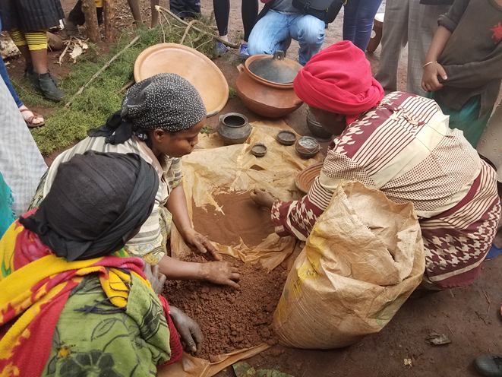 |  | 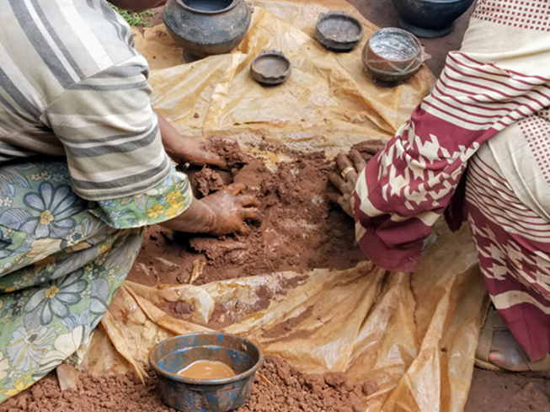
 | 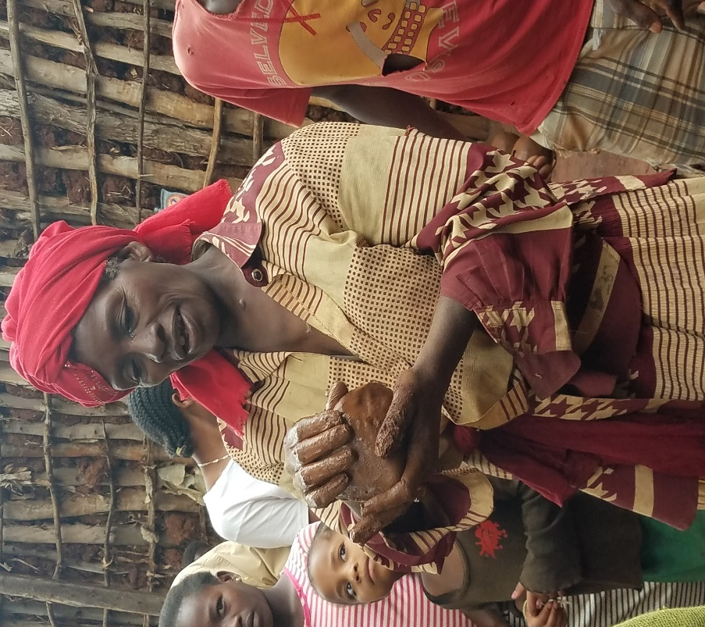 | 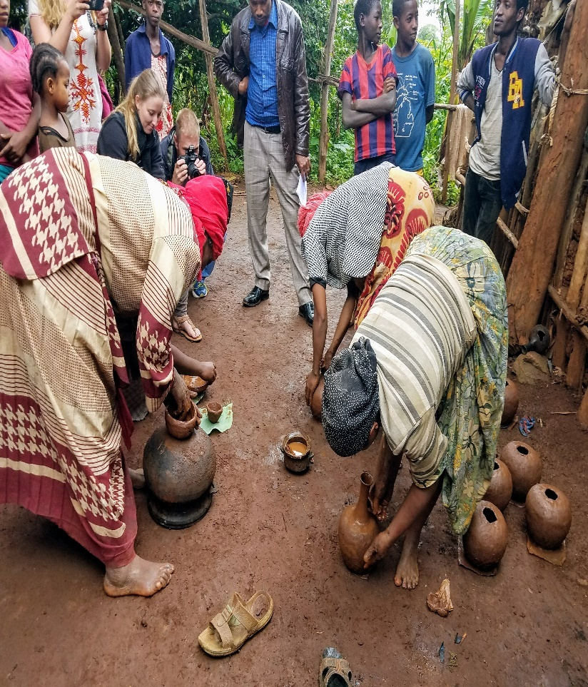

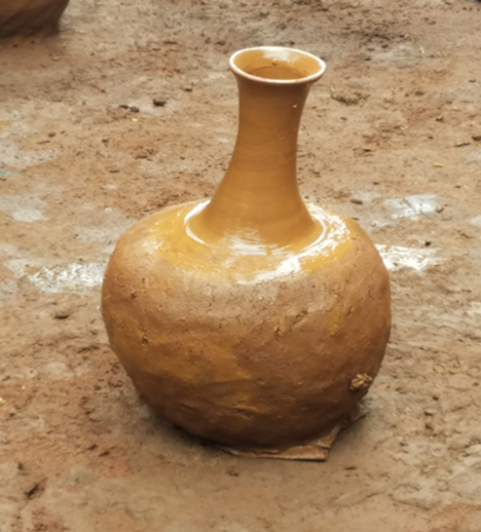 | 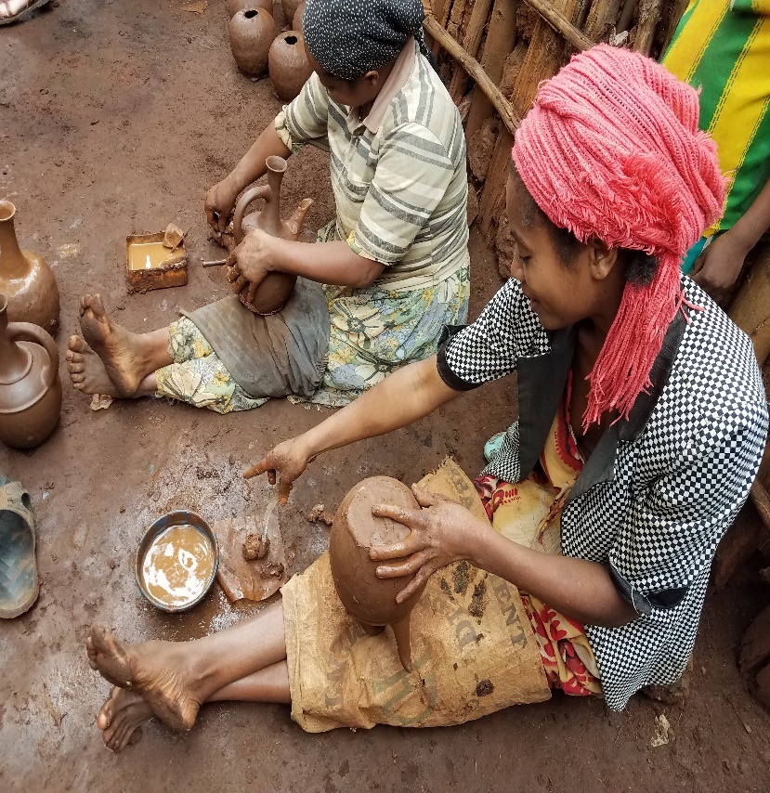
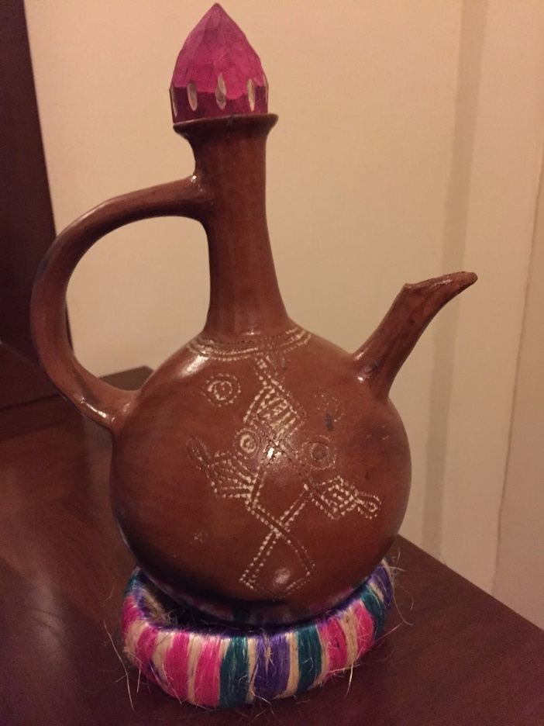

Pinch Pots

Students can make their own pinch pots or other useful storage containers out of clay. For a detailed lesson plan visit the lesson titled, “Buidling Communities with Community Objects” on the Fulbright-Hayes Ethiopian Fulbright-Hayes website.

Toothpick Structures
The wooden objects built in Ethiopia are mostly built from tree branches that are fastened together with nails. Using toothpicks to build different structures is a safe and engaging method that mimics the process Ethiopians use. There are numerous activities involving toothpick building activities that vary in complexity and time available on the Internet. The following activity has been adapted from Sylvan Learning (http://www.sylvanlearning.com/blog/index.php/summer_stem_challenge_marshmallow_engineering/)
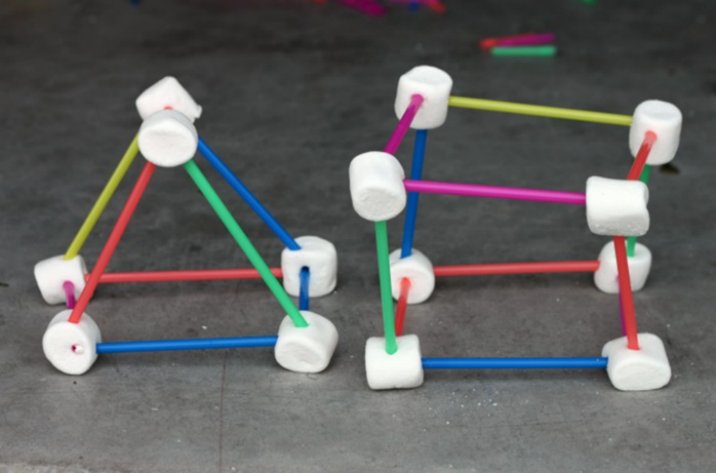
Lesson:
Marshmallows and s’mores are synonymous with summer fun and parents can build on that excitement with this fun and simple STEM (science, technology, engineering and math) project. Creating structures out of marshmallows develops kids’ engineering skills and enhances their critical thinking. It’s the perfect way for them to keep their EDGE this summer!
While creating marshmallow structures, kids are working on the STEM concepts of design, building, shape, and structure in a fun and hands-on way. It’s an open-ended process that allows them to build and rebuild designs while problem solving and develops higher level critical thinking.
We took the STEM concepts being taught in the Sylvan Edge classes and used them to become marshmallow engineers. In the process, my kids got the chance to problem solve and experiment with building and design.

Supplies needed:
- Marshmallows or mini-marshmallows (they hold better if they are a little bit stale)
- Plastic drinking straws or toothpicks (if using mini-marshmallows)
- Scissors
Start off the activity by asking the kids to make two-dimensional shapes with the supplies such as a square or a triangle. Then ask them to turn their 2-D shapes into 3-D ones by adding more sides. If they get stuck demonstrate how to turn a square into a cube.
Next, ask them what other types of structures they can build. Let them cut the straws or even the marshmallows if necessary to create the design they desire. As they work encourage them to “try something different” to overcome any problems they encounter. This open-ended exploration is a great way to investigate STEM concepts.
Extend the learning:
Give them simple challenges to get them to think critically and to make the process more fun!
- Build a two or three-story structure
- Create a marshmallow bridge
- Build a structure using only one shape
- Create a structure that can hold a piece of paper
Larger marshmallows can make it more challenging to build higher structures and mini-marshmallows limit the number of toothpicks that can be used in each one. Encourage kids to discover the limitations of the materials and add in more you may have around the house to achieve their goal. You’ll be surprised by just how creative they can be!

Design Your Own Flag
The reason why colors and symbols are chosen for national and tribal flags is interesting and offers unique insight into the history of that country. The descriptions of the Ethiopian flag are included below.
We recommend students design their own flags. They could be individual flags, family flags, or region flags. Students can draw their flag and write a description of why they chose specific colors and symbols.

Description of Ethiopian Flag
Description of the Ethiopian Flag
The flag of Ethiopia has three horizontal stripes of green, yellow, and red from top to bottom. Centered over these stripes is a blue circle, on which there is a yellow five-pointed star. The green, yellow, and red colors have been used frequently to represent the region, often called Pan-African colors. The green typically represents hope and the land's fertility, the yellow is for harmony among the Ethiopian people, and red represents valor and war, depicting the fight for independence and resistance to colonist takeover.
The bright star symbolizes the future of the nation, and may also reference King Solomon as the Star of David. Surrounding the five-pointed star are five yellow rays, symbolic of the equality of the diverse people of Ethiopia. (Maps of the World Website. https://www.mapsofworld.com/flags/ethiopia-flag.html)


Build a Recycled Toy
Toy stores are rare in Ethiopia. For entertainment, the majority of children make their own toys out of materials that are easily accessible. This often includes materials that are no longer used or thrown away. Wheels and sticks are very common. Other examples are included in the pictures in the main activity.
For this activity, students can use available recycled materials to try and build their own toy. Students can bring in recycled materials from home or use what is available at school. As an extension activity, students can create an advertisement for their toy. The following are some examples for students to answer:
- What is the name of the toy?
- How does it work?
- Who will play with it?
- How much will it cost?

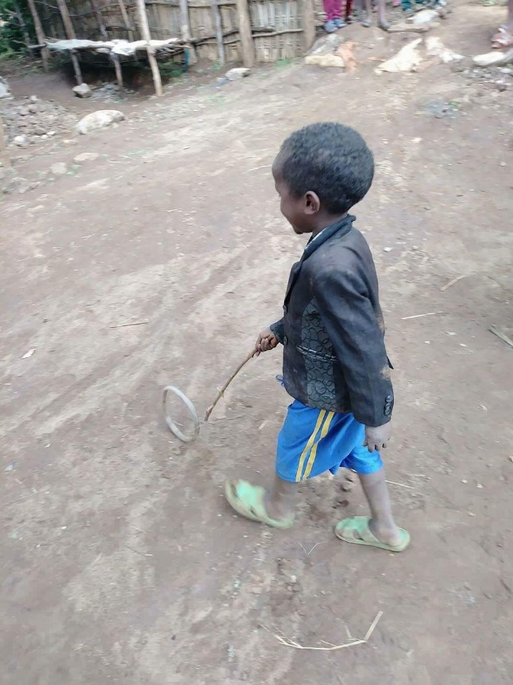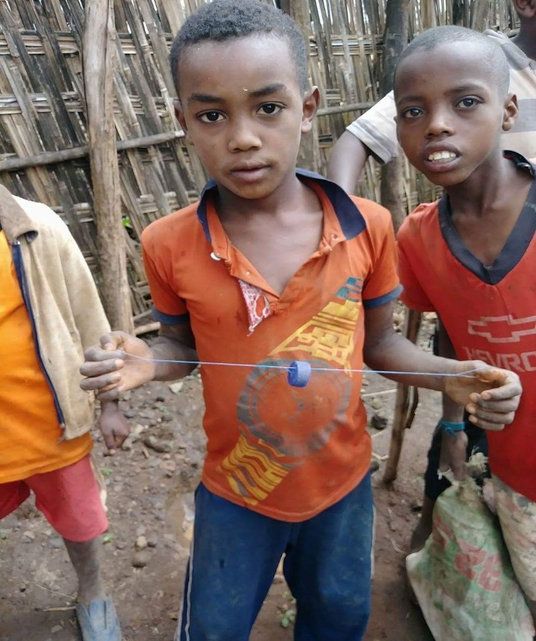

Mancala Game
Mancala is a popular counting game played in many different African nations. It has many different names and can be played by many different sets of rules. Mancala boards can easily be found wherever children’s games are sold. The following directions offer a suggestion about how kids can make their own Mancala board with an egg carton. One possible set of directions for the game is also suggested.
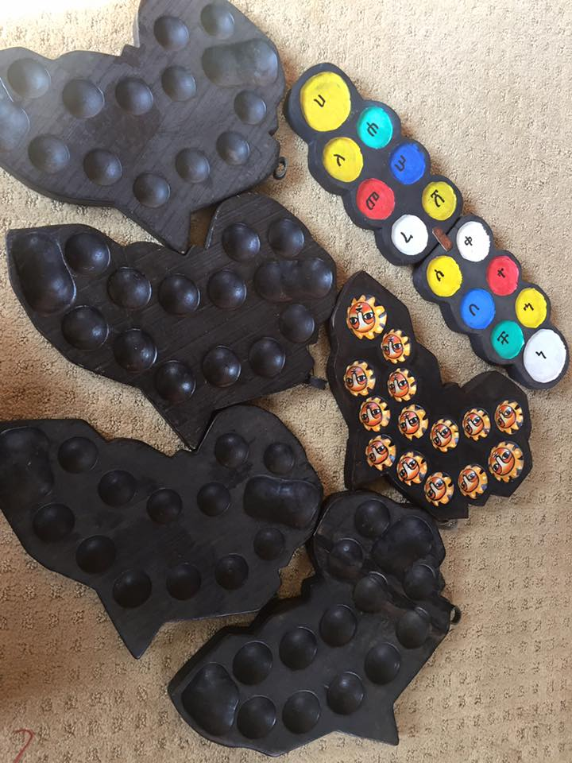

Instructions and rules adapted from education.com (https://www.education.com/activity/article/mancala/)
What You Need:
Egg carton
Two small bowls or boxes
48 beads, coins, seeds, or other small objects
What You Do:
Give the beads, coins, or other objects to your child, and have him place four objects in each trough of the egg carton.
Have her place one small bowl or box at each narrow end of the egg carton. These start out empty.
The game is played with two players, and the object of the game is to capture as many beads (or other objects) as you can.
To play, choose who goes first with a quick round of rock-paper-scissors. The first player picks up the beads from any trough on his side and carries them clockwise, dropping one bead in each subsequent trough. The bowl or box to that player’s right—called his store—also gets a bead dropped in it. Each player skips the opposing player's store.
The player’s turn is over unless the last bead he drops lands in his store. If it does, the player gets another turn, starting from wherever he wants. Once the player’s turn is over, the opposing player gets a turn.
Whenever a player lands a bead in an empty trough, he gets to collect the opposing player's beads in the trough opposite the one he landed in. The opponent's beads and his last bead get placed in his store.
Play continues in this way until one player is out of beads on his side. He then gets to collect the opposing player’s remaining beads. The player with the most beads in his bowl or box at the end of the game, wins.
Since the first player sometimes has an advantage in Mancala, make sure to alternate who goes first when you play. Keep the game board and beads together by shutting the egg carton tightly and storing it that way while you aren’t playing.

Design Your Own Food Labels
Companies like Coca-Cola have launched very successful ad campaigns to market their products across the globe. Coke and other soft drink products are common across Ethiopia and viewed as a special treat. Students should think of their favorite food. Using their background knowledge of Ethiopia, create a food label or advertisement that would make Ethiopians want to purchase their product.

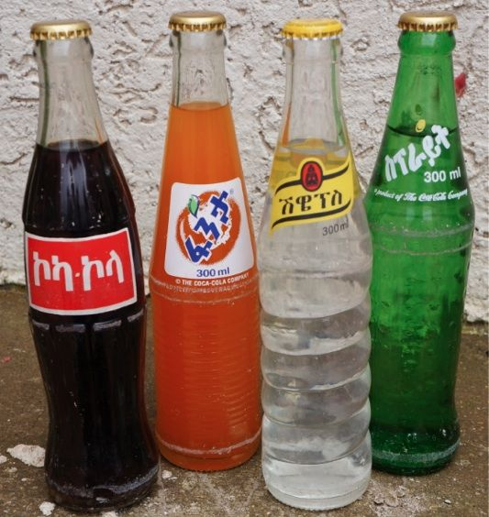

Mortar and Pestle
After discussing a mortar and pestle, allow students to attempt to grind up a food source using the tools. Coffee beans work best, but other spices will work as well. When finished, lead a discussion about the benefits and disadvantages of using these tools.

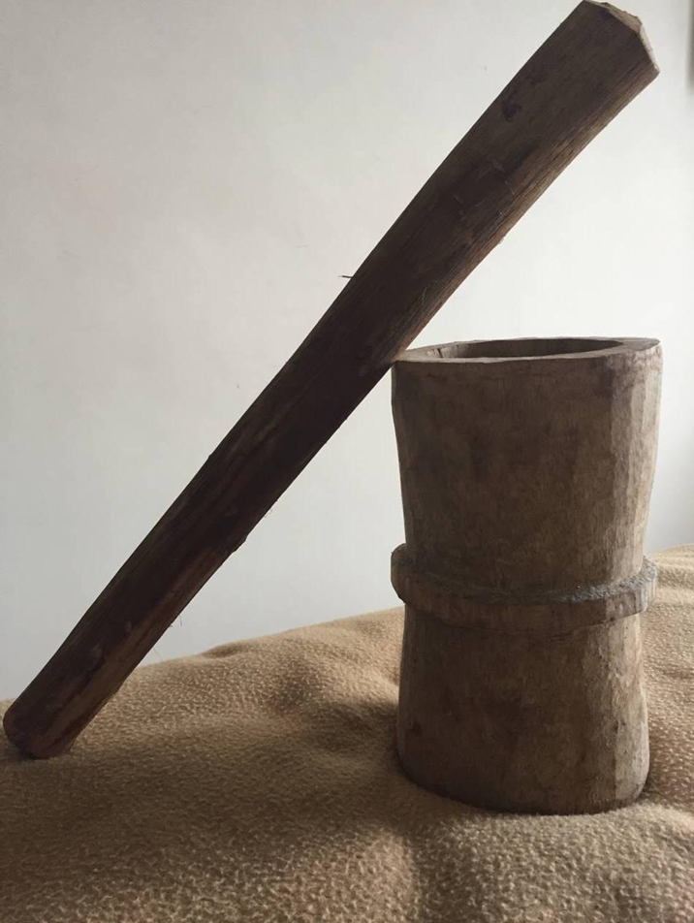

Your Shoe’s Story
Ethiopia is a culture full of stories. These stories exist in their vibrant folktales and proverbs. Ethiopian family and personal stories also offer a unique perspective on Ethiopian daily life. The personal stories of students can also offer a unique story about their family and community. Students can use their shoe as a story starter.
Story Starter Questions:
(Questions adapted from the Healing Stories website: http://healingstory.org/)

How did your shoes come into your life?
Where have your shoes taken you?
If your shoes were to introduce you, what would they say about you?
If another were to spend a day in your shoes, what might they experience?

